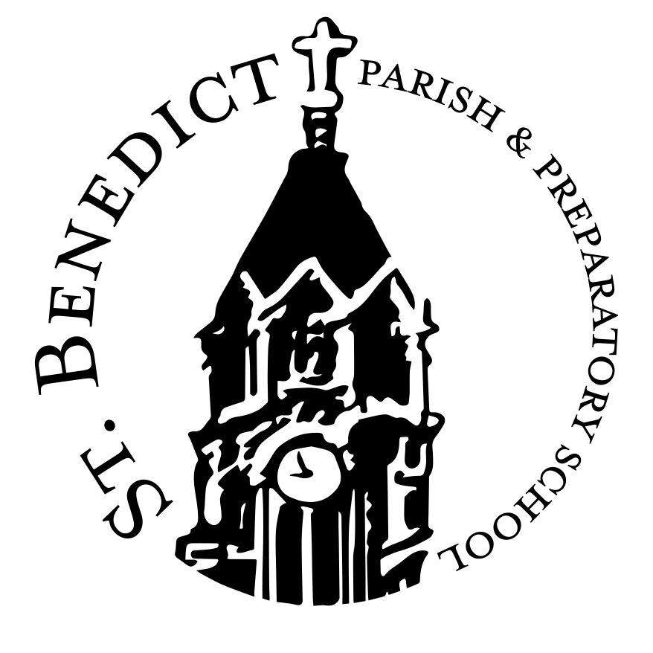
RECONCILIATION AND COMMUNION CALENDAR 2017-2018

September 30, 2017 All fees and forms due to the Religious Ed. Office

November 20, 2017 God Has Reconciled the World to Himself
Attendance is expected at 7 p.m. in the Church (adults only)

February 12, 2018 The Center of our Lives is the Eucharist
Attendance is expected at 7 p.m. in the Church (adults only)

March 3, 2018 OR FIRST RECONCILIATION (COMMUNAL RITE OF RECONCILIATION
March 5, 2018 WITH INDIVIDUAL CONFESSION AND ABSOLUTION – in Church)
Attend Sat., Mar. 3 at 9:15 a.m. or Mon., Mar. 5 at 6:00 p.m.

March 10, 2018 PARENT/CHILD RETREAT (Heidenreich Hall)
CHOOSE 3/10 Sign up for either 9 a.m. or 10:30 a.m.
OR 3/17
March 17, 2018 PARENT/CHILD RETREAT (Heidenreich Hall)
Sign up for either 9 a.m. or 10:30 a.m.
May 2, 2018 Communion Practice 4:30 p.m. for May 5 – 10 a.m. Mass
5:30 p.m. for May 5 – Noon Mass
May 5, 2018 FIRST COMMUNIONS 10 a.m. Mass (Limit 30)
(Saturday) Noon Mass (Limit 30)

May 5, 2018 FIRST COMMUNION 5 p.m. Mass (Limit 10)

May 6, 2018 FIRST COMMUNIONS 9 a.m. Mass (Limit 10)
(Sunday) 10:30 a.m. Mass (Limit 10)
Noon Mass (Limit 10)

May 11, 2018 Communion Practice 5 p.m. for May 12 – Noon Mass

May 12, 2018 FIRST COMMUNION (Sat.) Noon Mass (Limit 30)
Communion Photos will be taken before First Communions on May 6 and May 12.

